# CS 255 System Design Document Template

This template lays out all the different sections that you need to complete for Project Two. Each section has guidance to prompt your thinking. You will need to continually reference the interview transcript as you work to make sure that you are addressing your client’s needs. There is no required length for the final document. Instead the goal is to complete each section based on what your client’s needs are. Remove this note when you are finished, and replace all bracketed text with the relevant information.

## UML Diagrams

### UML Use Case Diagram

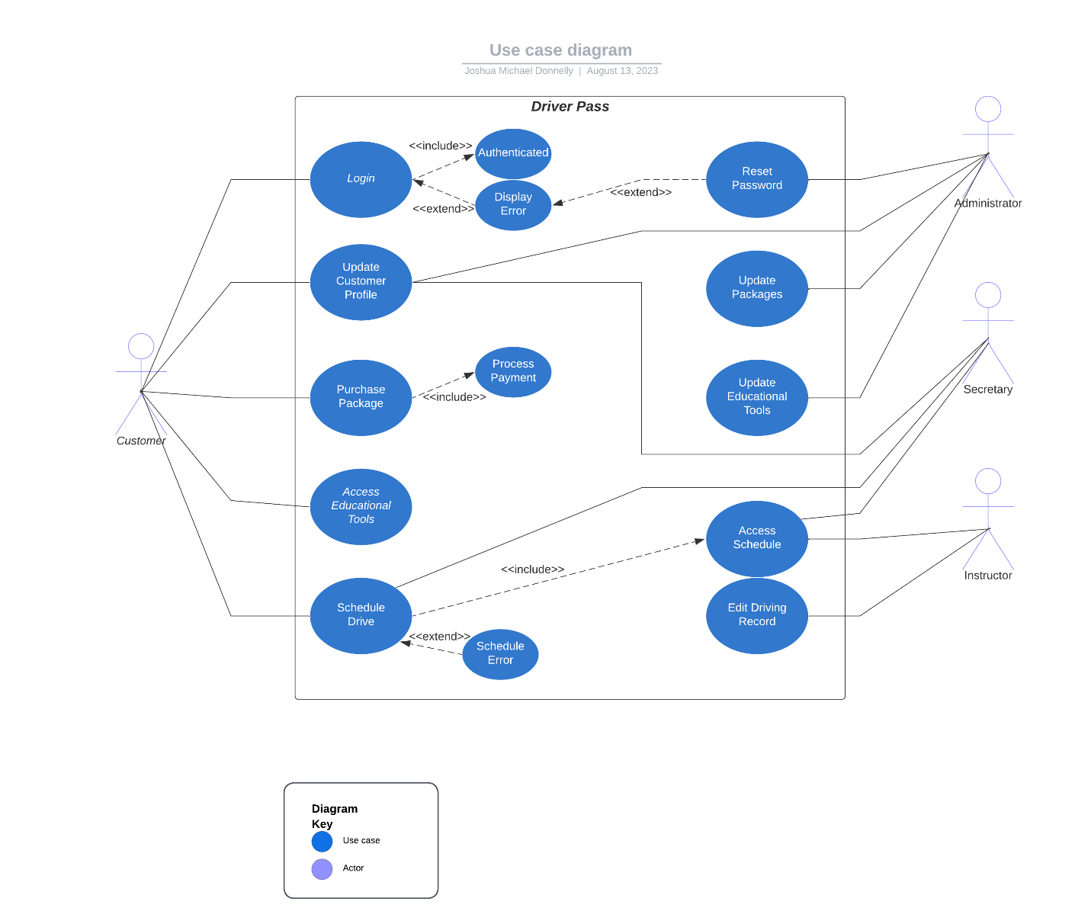

### UML Activity Diagrams

*[You were asked to choose* ***two*** *use cases and create* ***two*** *activity diagrams, one for each use case. Please insert* ***both*** *of your activity diagrams here. Check to make sure that you included appropriate components and symbols and that your design meets the client’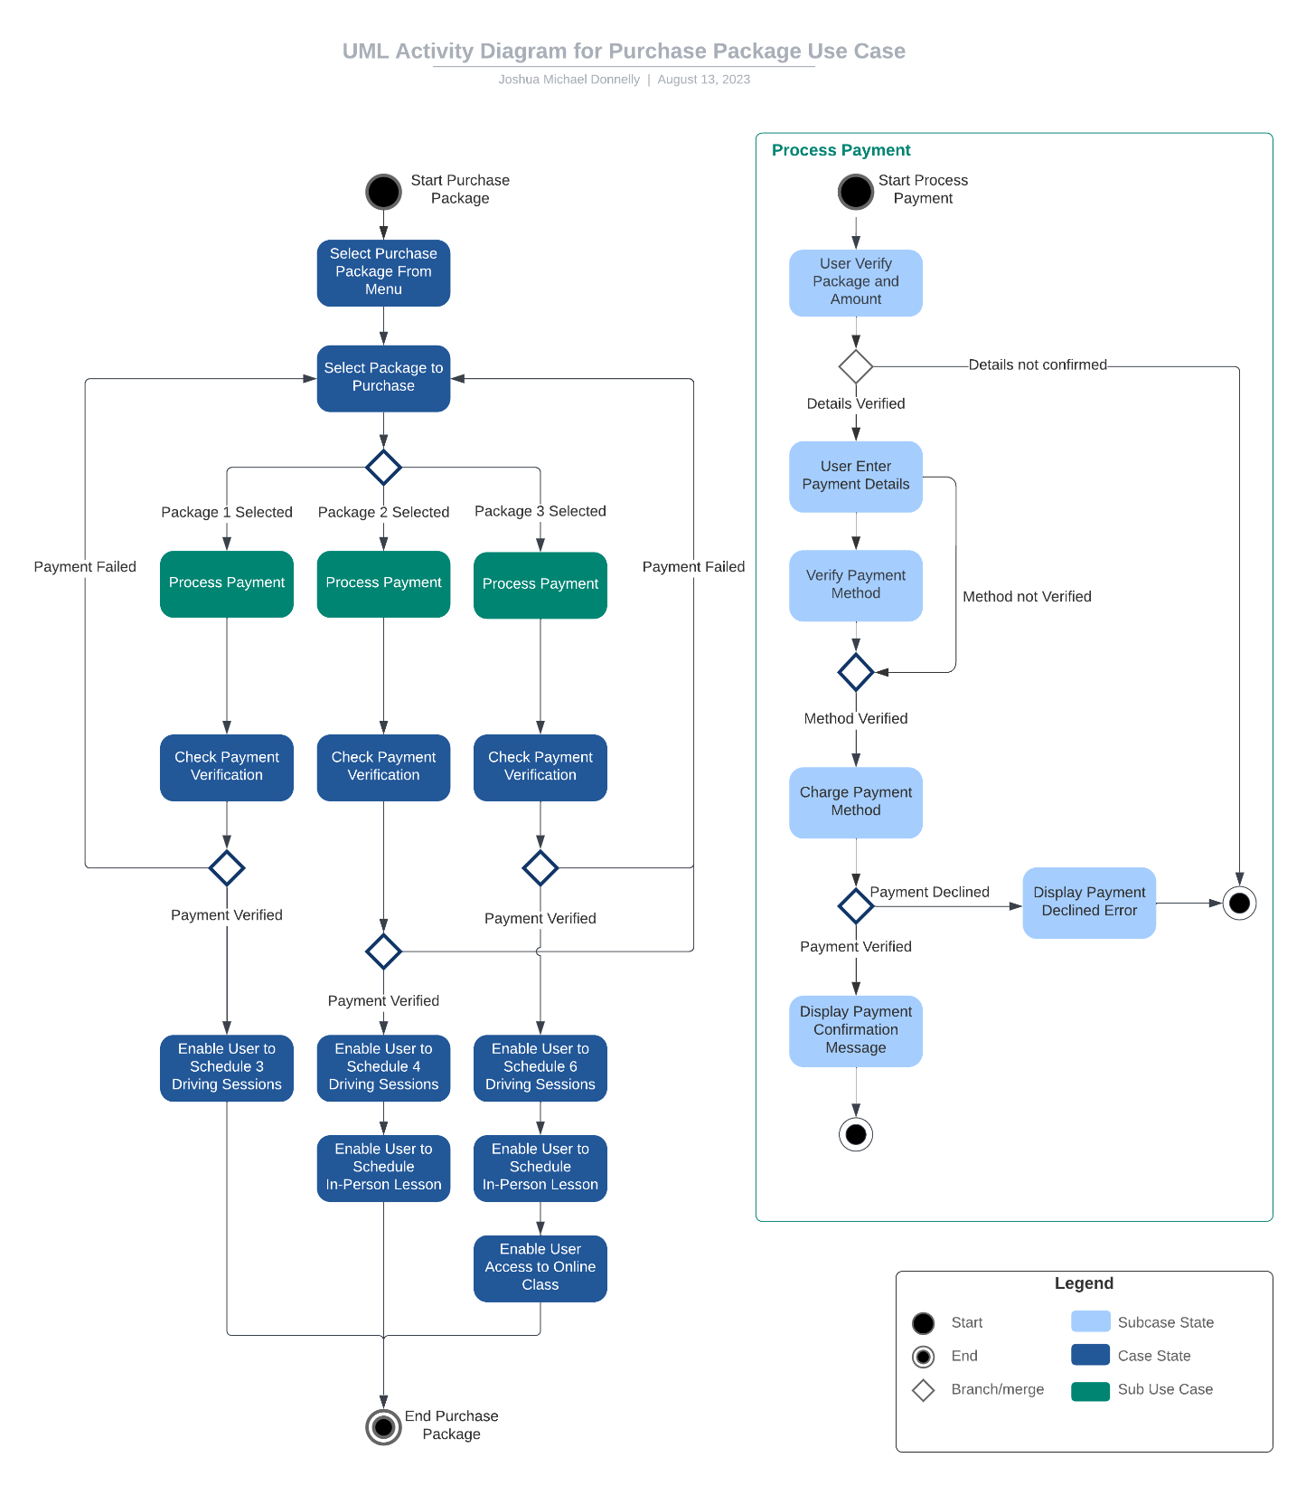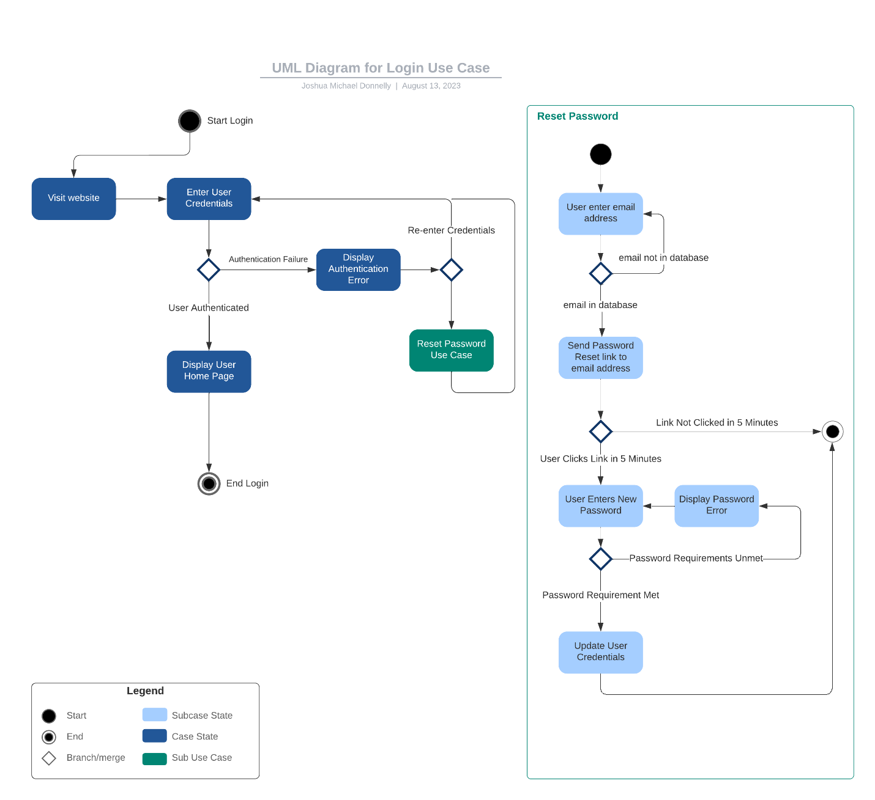*

### UML Sequence Diagram

*[You were asked to create a sequence diagram based on* ***one*** *of the use cases you chose. Please insert your sequence diagram here. Check to make sure that you included appropriate components and symbols and that your design meets the client’s needs.]*

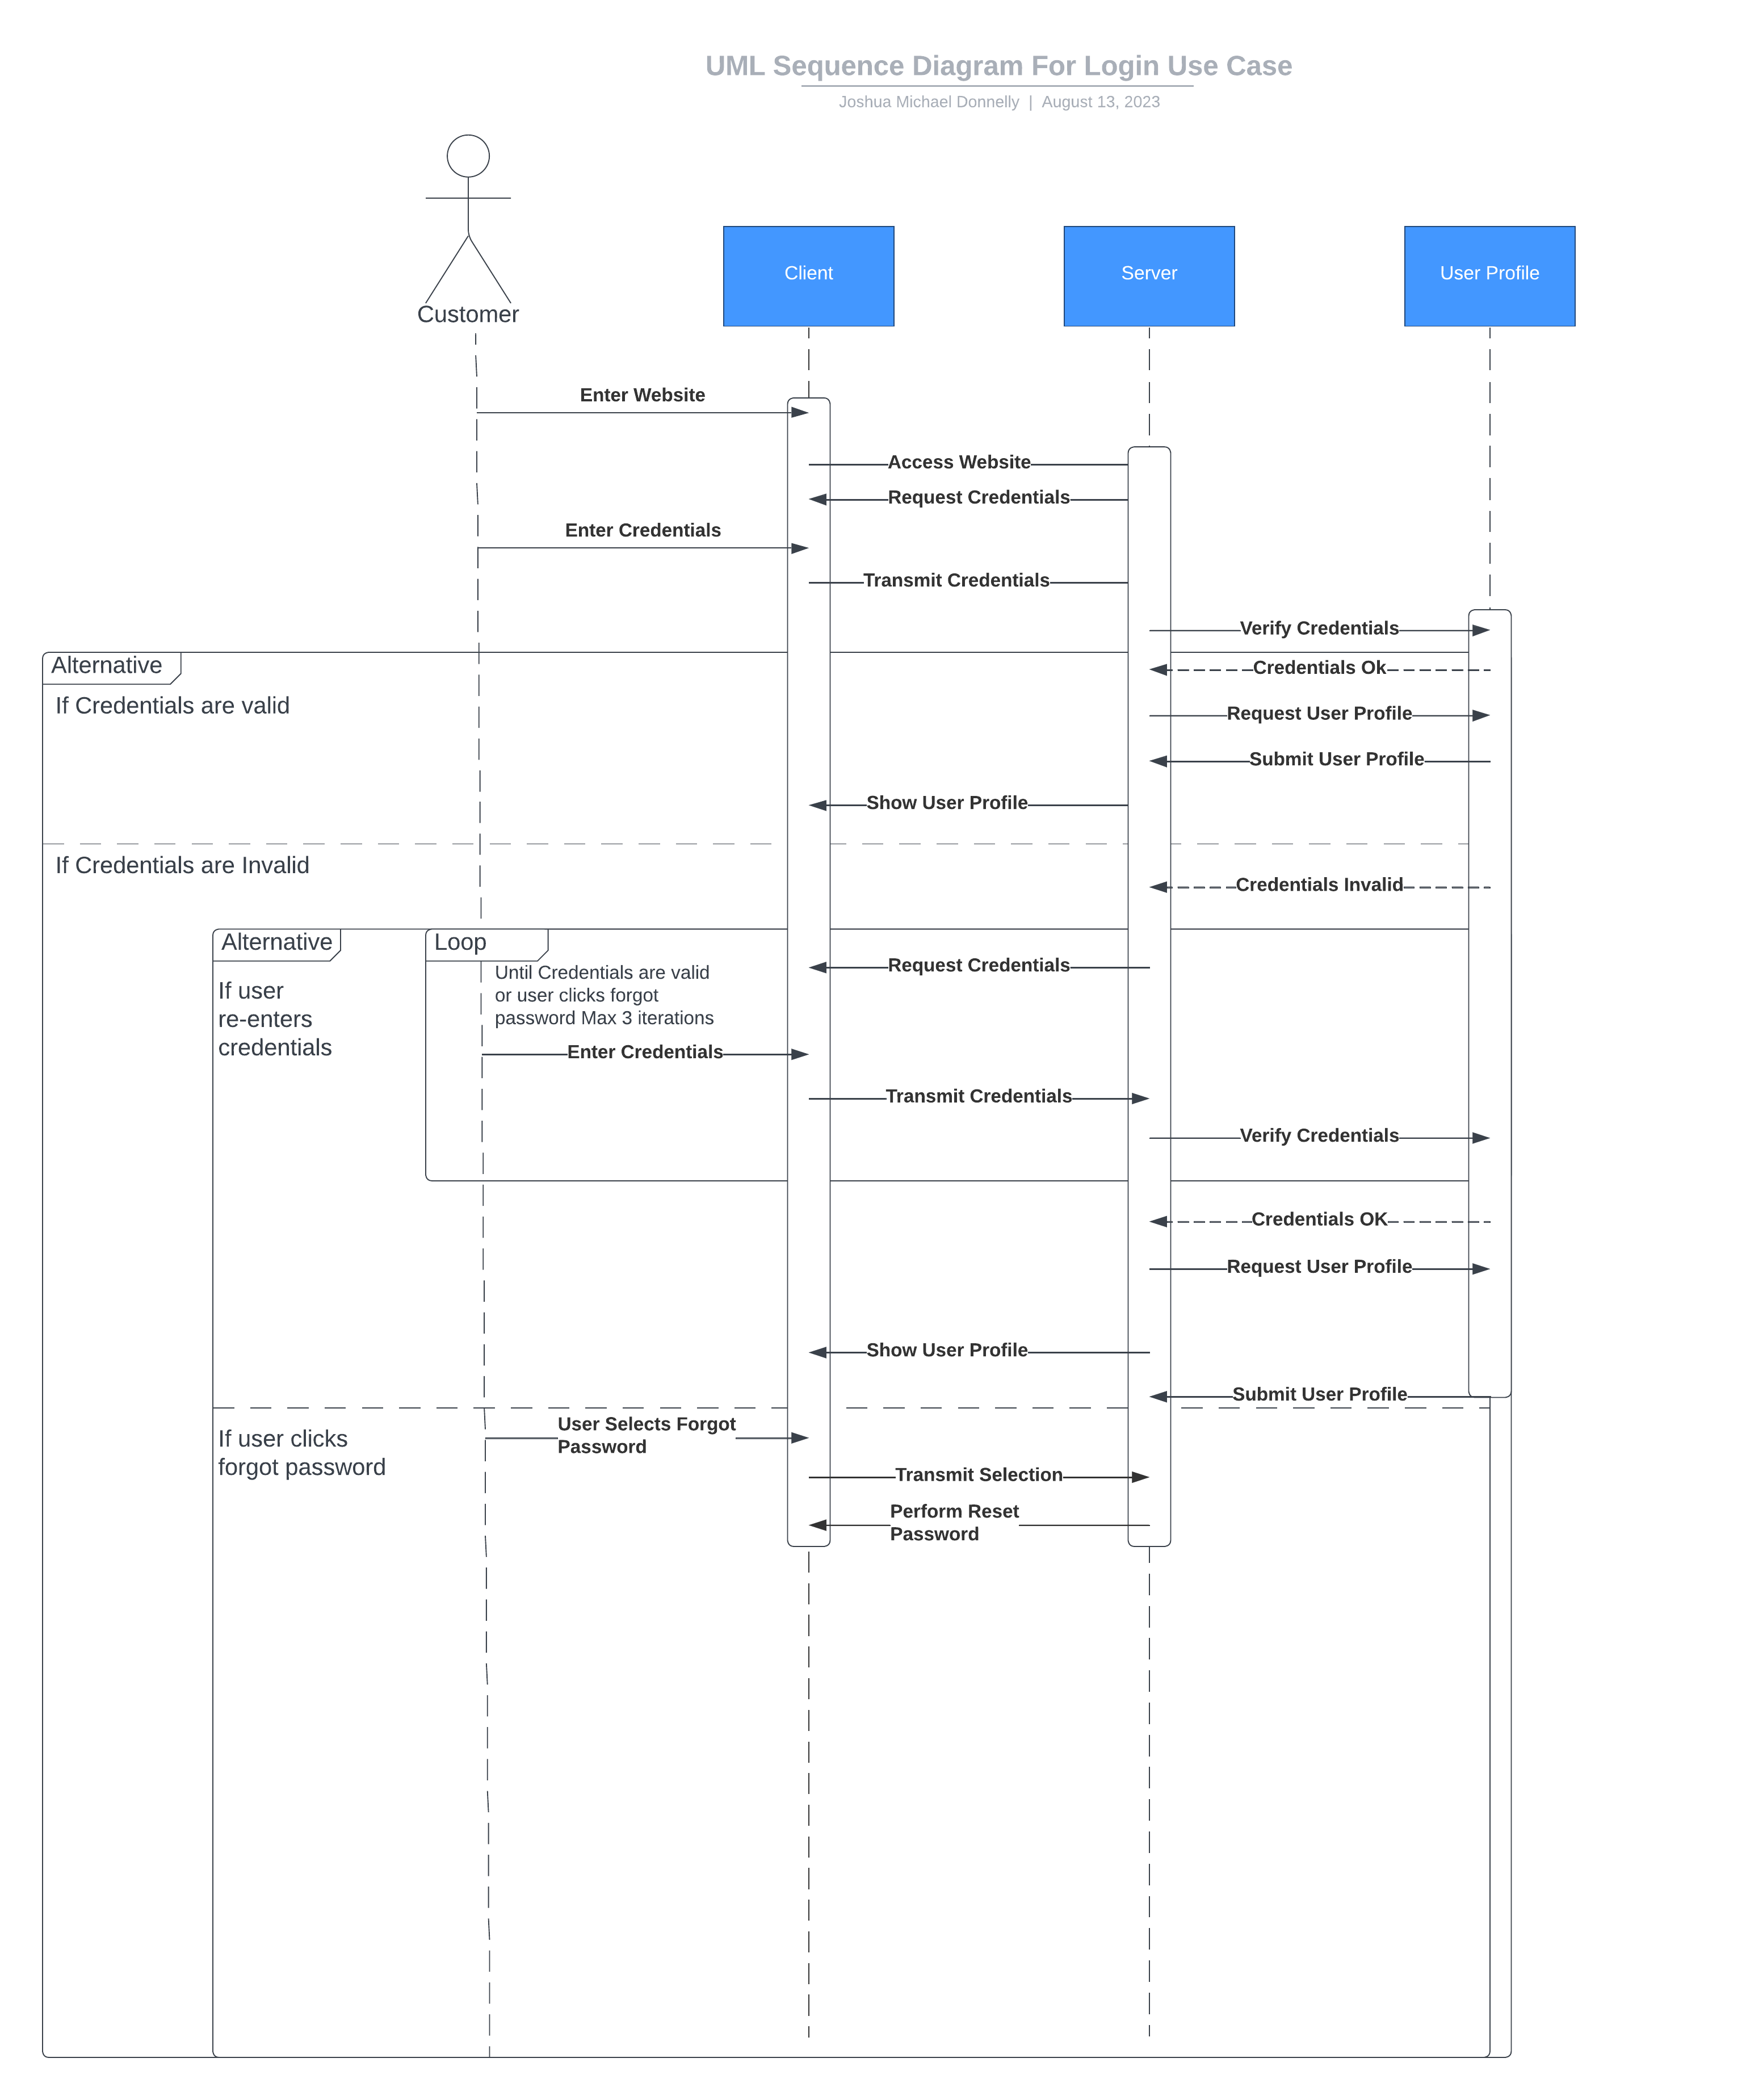

### UML Class Diagram

*[You were asked to create a class diagram based on the different classes and attributes needed for your system design. You are* ***not*** *required to include methods, but you may if you wish. Please insert your class diagram here. Check to make sure that you included appropriate components and symbols and that your design meets the client’s requirements.]*

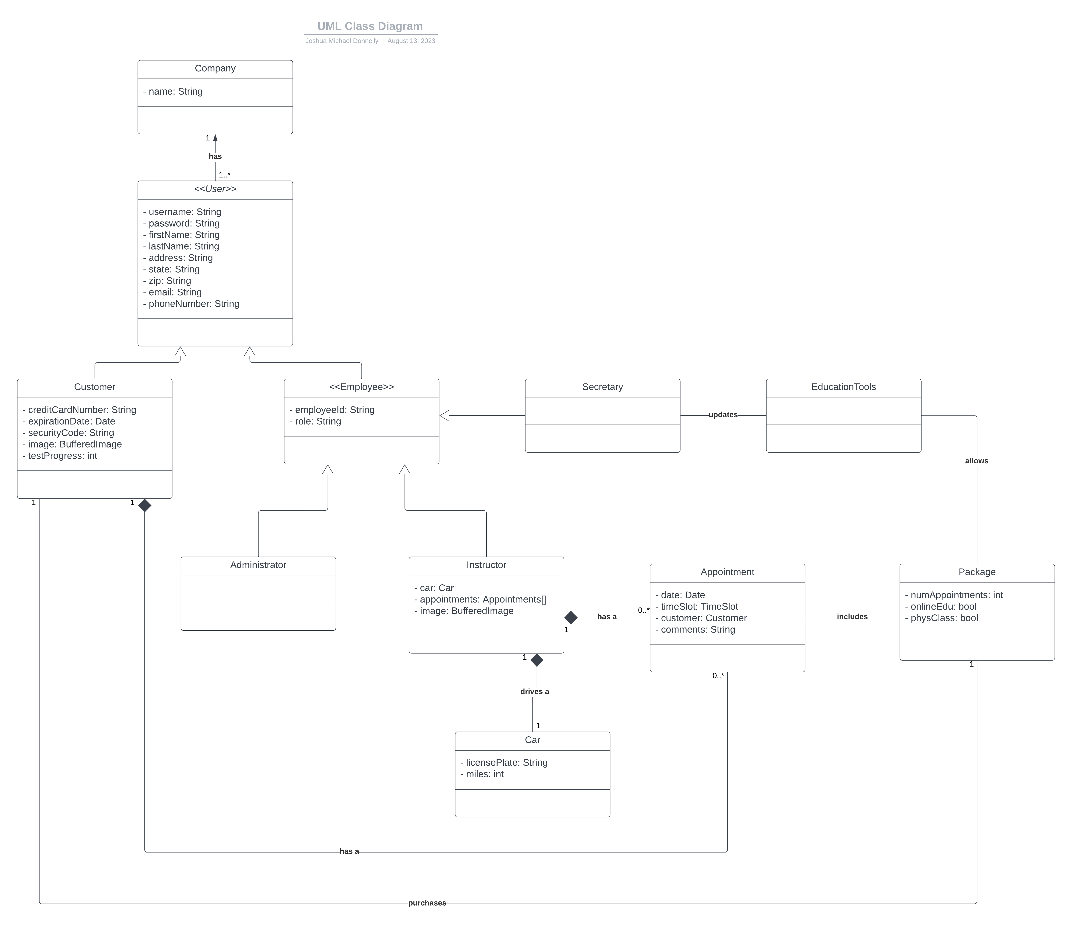

## Technical Requirements

*[Based on the diagrams you have created, describe the technical requirements of your system. These requirements should address the required hardware, software, tools, and infrastructure necessary for your system design.]*

The technical requirements for this system include a server for authentication and connection to the customer for online access and storage of some type to store the various information for the online tools. The ability to update the tools based on the DMV updates will also either require manual updates or an API connection to the DMV system. Having the ability to accept online payments will require some type of payment processing API as well. There will be the requirement of a domain in order for customers to connect to the system. There will need to be some sort of calendar in order to view make and modify appointments. The user interface will also need to be designed to show the information required.